**Research Paper**

**Develop A Smart Attendance**

**Capturing System**

**Abstract**

The main purpose of this project is to build a face recognition based attendance monitoring system for employees to enhance and upgrade the current attendance system into more efficient and effective as compared to before. The current old system has a lot of ambiguity that caused inaccurate and inefficient of attendance taking. Many problems arise when the authority is unable to enforce the regulation that exist in the old system. The technology working behind will be the face recognition system. The human face is one of the natural traits that can uniquely identify an individual. Therefore, it is used to trace identity as the possibilities for a face to deviate or being duplicated is low. In this project, face databases will be created to pump data into the recognizer algorithm. Then, during the attendance taking session, faces will be compared against the database to seek for identity. When an individual is identified, its attendance will be taken down automatically saving necessary information into a excel sheet. At the end of the day, the excel sheet containing attendance .

Keywords- Smart Attendance System,RFID,OpenCV,Numpy

# INTRODUCTION

This is a project about Develop A Smart Attendance Capturing System for taking Employee Attendance. In this chapter, the problem and motivation, research objectives, project scope, project contributions and the background information of the project will be discussed in detail. Facial recognition systems can be used to identify people in photos, videos, or in realtime. Facial recognition is a category of biometric security.

1.1 Problem Statement

According to the previous attendance management system, the accuracy of the datacollected is the biggest issue. This is because the attendance might not be recorded personally by the original person, in another word, the attendance of a particular person can be taken by a third party without the realization of the institution which violates the accuracy of the data.

For example, employee A is lazy to attend a particular shift, so employee B helped him/her to sign for the attendance which in fact employee A didn‟t attend the shift or not come on job , but the system overlooked this matter due to no enforcement practiced. Thus, all the recorded attendance in the previous system is not reliable for analysis usage. The second problem of the previous system is where it is too time consuming. Assuming the time taken for a employee to sign his/her attendance on a 3-4 paged name list is approximately 1 minute. In 1 hour, only approximately 60 students can sign their attendance which is obviously inefficient and time consuming. The third issue is with the accessibility of those information by the legitimate concerned party.

1.2 Research Objectives

In order to solve the drawbacks of the previous system stated in 1.1, the existing system will need to evolve. The proposed system will reduce the paperwork where attendance will no longer involve any manual recording. The new system will also reduce the total time needed to do attendance recording. The new system will acquire individual attendance by means of facial recognition to secure data accuracy of the attendance.

The following are objectives of the project:

▪ To develop a portable Smart Attendance System which is handy and self-powered.

▪ To ensure the speed of the attendance recording process is faster than the previous system which can go as fast as approximately 3 second for each student.

▪ Have enough memory space to store the database. ▪Able to recognize the face of an individual accurately based on the face database.

▪ Allow new employee to store their faces in the database by using a GUI.

▪ Able to show an indication to the user whether the face- recognition process is successful or not.. ▪ Develop a database for the attendance management system.

▪ Provide a user-friendly interface for admins to access the attendance database and for non-admins to check their attendance by mailing the attendance.

1.3 Project Scope

The followings are the project scopes:

▪ The targeted groups of the attendance monitoring system are the employee and manager

▪ The database of the attendance management system can hold up to 5000 individual‟sinformation.

▪ The facial recognition process can only be done for 1 person at a time.

▪ An excel sheet is created which contains the employee attendance and is mailed to the respected.

▪ The device on which the application is running is powered up by power bank to improve the portability of the application.

## LITERATURE SURVEY

### 2.1 Fingerprint Based Attendance System Using Microcontroller and LabView

The third research journal “Fingerprint Based Attendance System Using Microcontroller and LabView” (Kumar Yadav, Singh, Pujari, Mishra, 2015) proposed a solution of using fingerprint to mark the attendance. This system is using 2 microcontrollers to deal with the fingerprint recognition process. Firstly, the fingerprint pattern will be obtained through a fingerprint sensor, then the information will be transmitted to microcontroller 1. Next microcontroller 1 will pass the information to microcontroller 2 to do the checking with the database that resides in it. After finding a student‟s match, the details are sent to the PC through serial communication to be displayed. This design is good as it accelerates development while maintaining design flexibility and simplifies testing. But again, this system is attached to a PC which make it not portable. Other than that, the database information cannot be accessible easily. Meaning that, for the parents whom are interested in knowing their child‟s attendance cannot easily or conveniently access the information. Therefore, to provide accessibility of the student‟s information to the legitimate concerned party, the information can be uploaded to a web server for easy access. While the authentication for the appropriate access can be enforced through a login screen.

### 2.2 Face Recognition Based Attendance Marking System

The second research journals “Face Recognition Based Attendance Marking System” (SenthamilSelvi, Chitrakala, Antony Jenitha, 2014) is based on the identification of face recognition to solve the previous attendance system‟s issues. This system uses camera to capture the images of the employee to do face detection and recognition. The captured image is compared one by one with the face database to search for the worker‟s face where attendance will be marked when a result is found in the face database. The main advantage of this system is where attendance is marked on the server which is highly secure where no one can mark the attendance of other. Moreover, in this proposed system, the face detection algorithm is improved by using the skin classification technique to increase the accuracy of the detection process. Although more efforts are invested in the accuracy of the face detection algorithm, the system is yet not portable. This system requires a standalone computer which will need a constant power supply that makes it not portable. This type of system is only suitable for marking staff‟s attendance as they only need to report their presence once a day, unlike students which require to report their attendance at every class on a particular day, it will be inconvenient if the attendance marking system is not portable. Thus, to solve this issue, the whole attendance management system can be developed on an portable module so that it can be work just by executing the python program.

### 2.3 RFID based Student Attendance System

According to the fourth research journal “RFID based Student Attendance System” (Hussain, Dugar, Deka, Hannan, 2014), the proposed solution is almost similar to the first research journal where RFID technology is used to improve the older attendance system. In this system, a tag and a reader is again used as a method of tracking the attendance of the students. The difference between the first journals with this is where attendance‟s information can be accessed through a web portal. It provides more convenient for information retrieval. Again, this system is imperfect in the sense that, firstly, it is not portable, as the RFID reader can only work when it is connected to a PC. Secondly, the RFID tag is not a guanine information that can uniquely identify a student, thus, resulting in the inaccuracy of the collected attendance information.

**SOFTWARE DESIGN**

We can design our system in such a way that it is easily understand and we see in abow diagrams.

1. **FLOW CHART**

In this diagram we will understood that who data can be flow how the system can work that firstly we get start then we register on our system we make login then our face is captured and person details can be display on the screen.

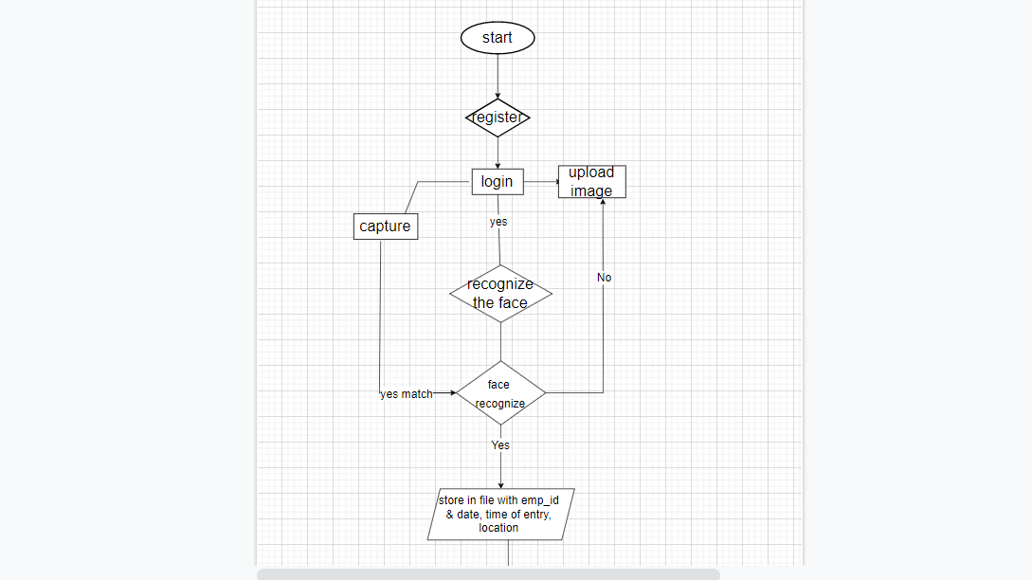

2.

**ER Diagram**: - In this diagram we see the relations between different entities and due to this we make tables in database.

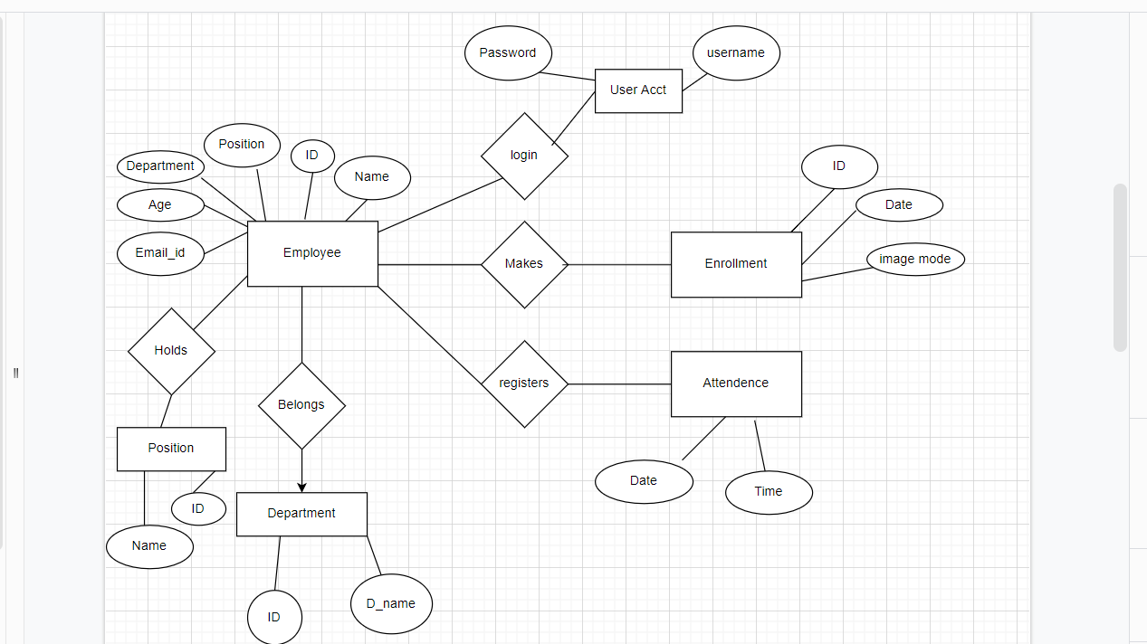

**Methodology**

### 1. Dataset Creation

We have use MYSQL workbench for making data of peoples for storing our data in proper format in rows and columns.

And for storing data of images, we create a folder for this and give the folder name as data and all the images will be stored in this folder. We can store 100 images of 1 person and also train this image by trainer.

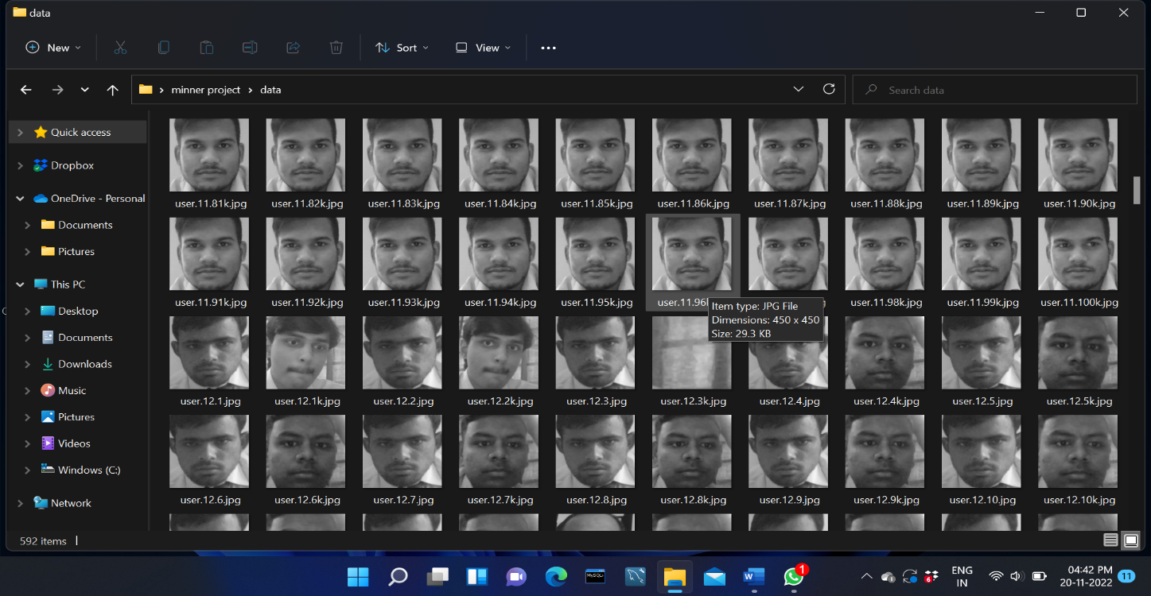

#### Face Recognition

Our Face recognition process can be divided into three steps-

Taking sample of the users, prepare training data, train face recognizer. Here training data will be the images present in our dataset.in data set we give an integer value to each users. These images are then used for face recognition. Face recognizer used in this system is Local Binary Pattern Histogram. Initially, the list of local binary patterns (LBP) of entire face is obtained.

Person face can be detected by this system and attendance can be marked by this firstly, a person can register and login into the system and give the image and this image is capture by the web camera of system with the help of open CV library in python also by using Har cascading style sheet and in this system when the user can come on the front of the camera so the user’s name, id and other details are display on the screen and their attendance can be marked by this.

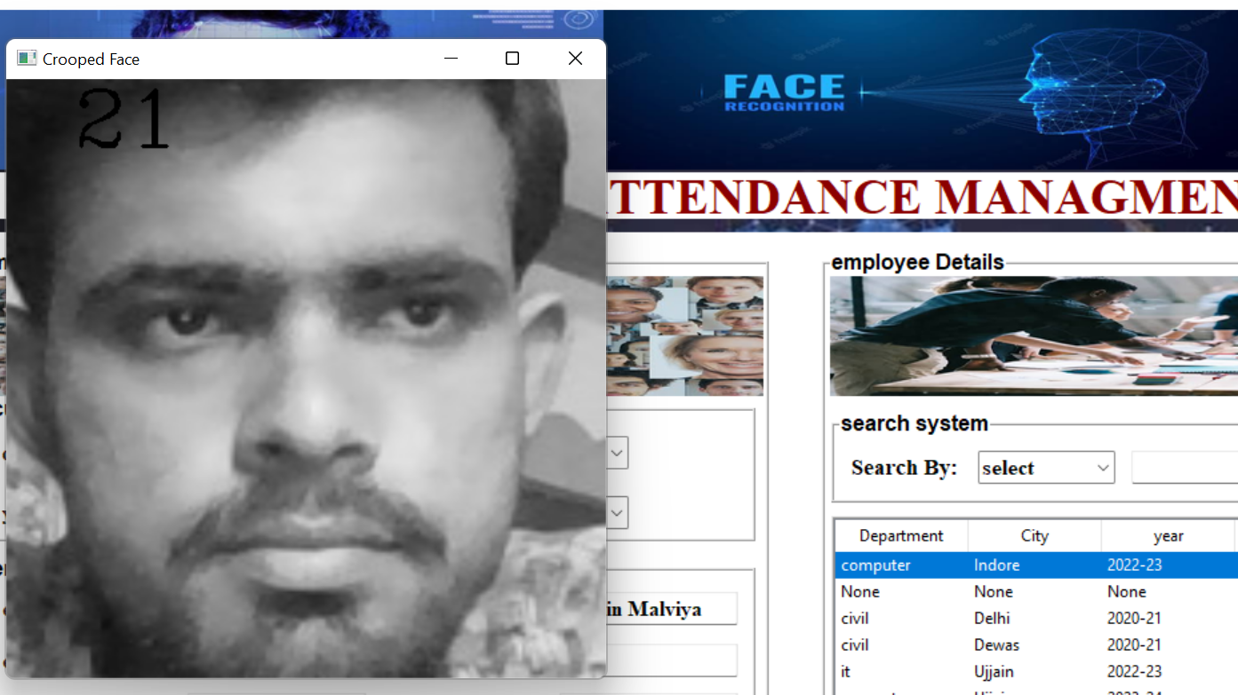

#### 2. Attendance Updation

After face recognition process, the recognized faces will be marked as present in the excel sheet and the rest will be marked as. Manager will be updated with monthly attendance sheet at the end of every month.

RESULTS AND DISCUSSIONS

The employee will fill all the basic details once on employee details option and also give 100 photos samples . The photos will train in tain option and save in database this process is only for new employees.

Here users will be mainly provided with eight different options such as, employee details, train data , photos , Face Recognition , Attendance, help(Chatbot), Developer, Exit other workers registration, and mark attendance. The company are supposed to enter all the required details in the employee registration form. After clicking on register button, the web cam starts automatically and window as shown pops up and starts detecting the faces in the frame. Then it automatically starts clicking photos until 100 samples are collected . These images then will be pre-processed and stored in training images folder. The manger are supposed to register with the respective department codes along with their email-id in the manager registration form provided. Using Face recognition employee mark there attendance .

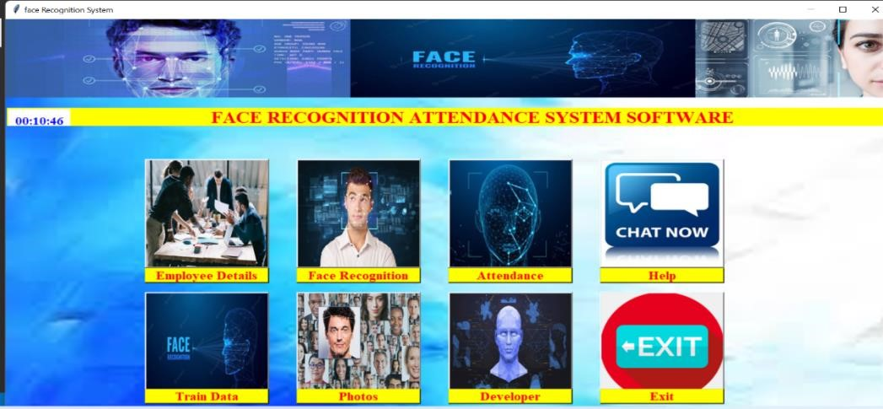

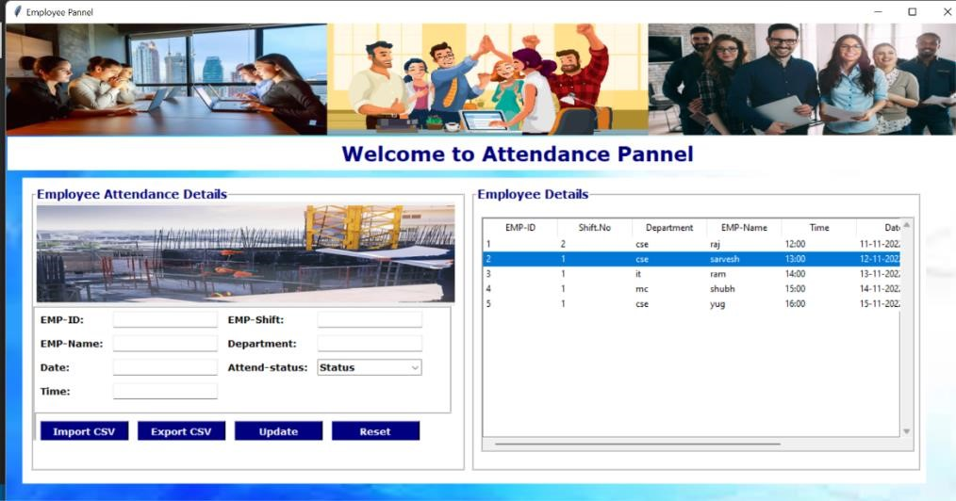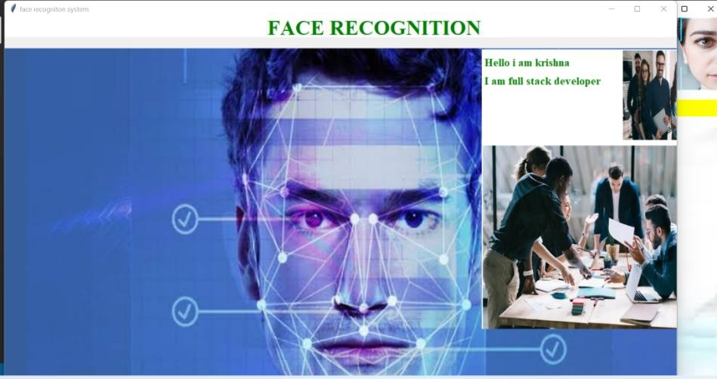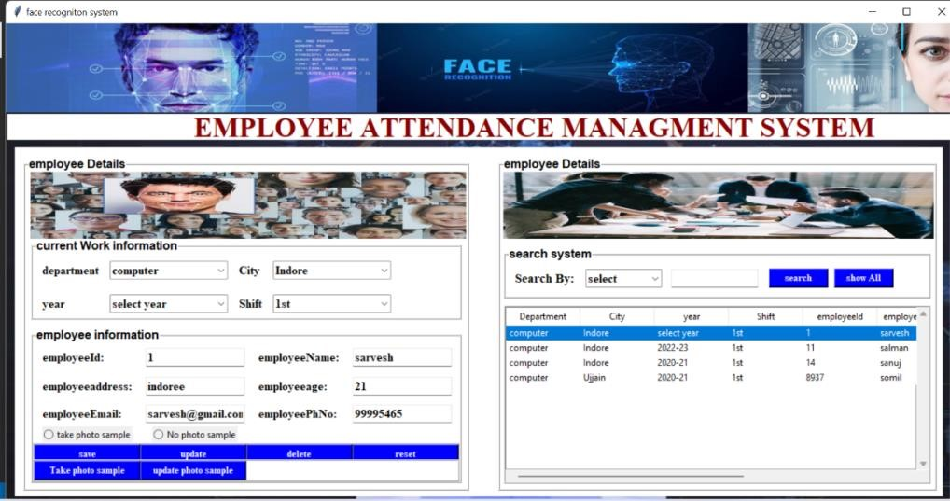

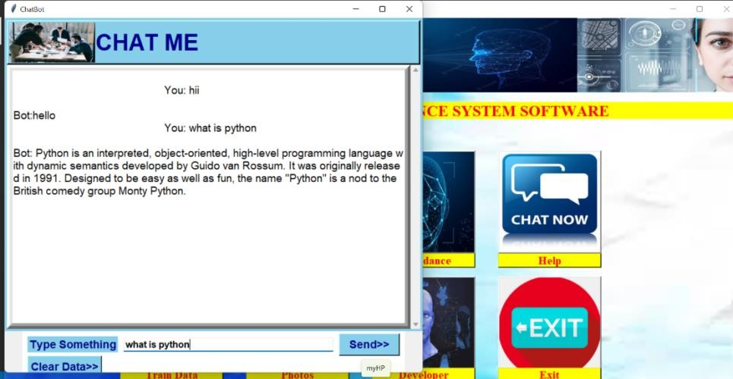

### CONCLUSION

This system aims to build an effective company attendance system for employee using face recognition. The proposed system will be able to mark the attendance via face. It will detect faces via webcam and then recognize the faces. After recognition, it will mark the attendance of the recognized employee and update the attendance record. It has chatbot and attendance management system .

### REFERENCES

[1] ttps://www.researchgate.net/publication/326261079_Face_d etection_system_for_attendance_of_company’_employes [2] Hapani, Smit, et al. "Automated Attendance System Using Image Processing." 2018 Fourth International Conference on Computing Communication Control and Automation (ICCUBEA).

IEEE, 2018.

[3] Rathod, Hemantkumar, et al. "Automated attendance system using machine learning approach." 2017 International Conference on Nascent Technologies in Engineering (ICNTE). IEEE, 2017 ; "Implementation of face recognition algorithm for biometrics based time attendance system." 2014

International Conference on ICT For Smart Society (ICISS). IEEE, 2014.